**SOP** **Number** Voy.01

Property List/Flex List

|  |  |  |  |  |
| --- | --- | --- | --- | --- |
|  | **NAME** | **TITLE** | **SIGNATURE** | **DATE** |
| **Author** | A.Kalantri |  |  |  |
| **Reviewer** | Edwin Gomez | Software Support Specialist |  |  |
| **Authorizer** | Shanette Silva | Director of Software Support |  |  |

|  |  |
| --- | --- |
| **Effective** **Date:** | 9/22/23 |
| **Review** **Date:** |  |

# PURPOSE

There will be requests from CM’s, RM’s, or RVP’s requesting for a user to receive access to multiple properties. This SOP details the policies and requirements considered needed to fulfill such requests

# SCOPE

Assess requests where a need is presented for a property list, some being for short-term or long-term usage. Short-term usage will require the use of a Flex property list. Long-term usage is reserved for Operational Leader roles in which no expiration period is observed and a personal list for the user is created. These lists are created upon the creation of the Voyager user profile either via the weekly new hire report or via one-off requests received via ticketing system.

# DEFINITIONS

Flex List = Flexible Property List

RM = Regional Manager

RVP = Regional Vice President

VP = Vice President

# RESPONSIBILITIES

The AGA agent will assess the type of property list needed by considering the use. If creating a brand new Voyager user for either a RM, RVP, or VP role, a personal property list should be created per the procedures detailed below. For flex property lists, You must receive an estimated time frame on how long the user will be needing this additional property access. Setup and management of this list is detailed below.

# SPECIFIC PROCEDURE

Creating a personalized Property List

To create a new property list you will follow the next steps and use naming convention listed below.

* Property List – you will list the job title initials first and then you will list the first name

initial and then you will use the next few letters of the last name.

**Example**: Community Manager named Bryant Falcon (cm-bfalc) (la-ahall)

* Description – You will list the full job title and the users full name.

**Example:** (Community Manager – Bryant Falcon)

* Property/ Entity List – Here is where you will list all property codes needed.

Percent – Percent should always be 100

Using a Flex Property List

To locate a Flex Property List you will need to search “flex” in the property list search bar.

Once you select an available list to use you will edit the list by updating the following fields.

* Description – You will delete the word “Available” and replace it with The users full name, Zendesk Ticket number, and expiration date (mmddyyyy)
* Property/ Percent – List property codes and set to 100%

Permanent Property List

If RM or RVP approved the request for permanent property access to the users, then we cannot use the Flex property list. Instead, we need to create a new property list.

Please see below a screen snap of the permanent property list which I created and confirmed with Shanette.

Prop list code should be “usercode”

Description – Username Permanent Property List.

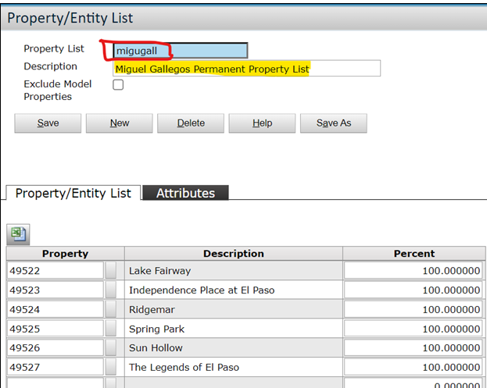

# FORMS/TEMPLATES TO BE USED

N/A

# INTERNAL AND EXTERNAL REFERENCES

N/A

* 1. **Internal** **References**

N/A

* 1. **External** **References**

N/A

# CHANGE HISTORY

* SOP No: Voy.01 Property Lists V.1
* Effective Date: 9/22/22
* Significant Changes: Initial Version
* Previous SOP no:.N/A

|  |  |  |  |
| --- | --- | --- | --- |
| **Version** | **Effective** **Date** | **Change Details** | **Review By** |
| V.1 |  |  |  |
|  |  |  |  |
|  |  |  |  |
|  |  |  |  |

Page 3 of 3